Background and Development Options
for Affordable Housing on 50-52 Coxe Avenue
Background
Buncombe County is working to transform underused County-owned properties into affordable housing. The County hired the Development Finance Initiative (DFI) at UNC Chapel Hill’s School of Government in September 2022 to help meet the County’s goal to deliver at least 1,500 affordable rental units for low- and moderate-income households by 2030.

In March 2023, following the results of an initial evaluation of publicly-owned properties, the Buncombe County Board of Commissioners prioritized 50-52 Coxe Avenue for development. DFI then began a pre-development process to identify public interests specific to this location. Those interests were then used to guide the development of conceptual plans that meet market needs, are compatible with the site and neighboring uses, and will extend limited public resources by attracting private funding.

Today, the County and DFI are requesting community input on which plan, if any, best meets the public interests. At the in-person and virtual input sessions, the community will have the opportunity to review multiple options along with the level of public investment expected for each.

Once a preferred plan is selected, the County and DFI will lead a competitive process to identify a qualified private development partner for each project. Development of the sites will occur only once important agreements that secure the public interests are executed between the County and its development partner(s).

Guiding Public Interests
In the first series of meetings with community members in April 2023, participants were asked to share their goals for development of the property. A memo summarizing the feedback heard is available on the County’s public input page (link below). Based on the County’s established housing goals and the input received, the following public interests were endorsed by the Buncombe County Board of Commissioners in August of 2023:

Redevelopment of the 50-52 Coxe Avenue site should:
- Maximize the number of new apartments affordable to low- and moderate-income households in a mixed income setting.
- Include active ground floor uses that serve residents and commuters and increase pedestrian traffic along Coxe Avenue.
- Maintain direct and safe access from Coxe Avenue to Church Street for pedestrians and cyclists.
- Balance maximum density and pedestrian-friendly design that extends the vibrant, urban streetscape from Patton Avenue to the South Slope area.
- Attract as much private investment as possible in order to maximize the impact of public investment in affordable housing.

DFI worked with the architecture firm McMillan Pazdan Smith (MPS) to explore ways the property could be developed given the public interests, physical site limitations, and local regulations. MPS created multiple plans including options with more or less residentials units of various designs and heights with commercial uses on the first floor. DFI then estimated the total construction cost for each scenario and estimated the sources of debt and funding the private partner would likely be able to secure. With any development that restricts rents to keep those rents affordable, a funding gap is likely to exist once private or non-charitable sources, including Low-Income Housing Tax Credit equity, are exhausted. The County’s potential investment in any project will be to fill the funding gap for the development of units that are reserved for low- and moderate-income households.

Opportunities for Public Input and Next Steps
Following the community input sessions, DFI will summarize the feedback received and present the preferred options to the Board of Commissioners. The plan that is selected will then be shared with potential development partners, who will be asked to submit a proposal that outlines how their experience and approach will best help the County meet its goals for development of the site.
Follow www.PublicInput.com/AffordableHousingDevelopment for updates and additional opportunities for engagement or contact Sarah Odio, odio@sog.unc.edu, DFI Associate Director.

Option 1: 52 Coxe Avenue
Proposed Development Program
- 130 multifamily (rental) units
All units restricted & affordable to households earning <80% AMI
  - 30% AMI: 29 units
  - 50% AMI: 9 units
  - 60% AMI: 66 units
  - 80% AMI: 26 units
- 2,200 square feet of ground floor, non-residential space
- 83 parking spaces
- Estimated public-private investment: $38.6 million
  - Potential Buncombe County participation: $4.2 million ($32,200 per unit)
    - Assumes use of both 9% and 4% low-income housing tax credit (LIHTC).

COXE AVENUE
RAVENSCROFT
SAWYER ST.

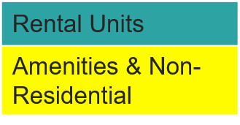

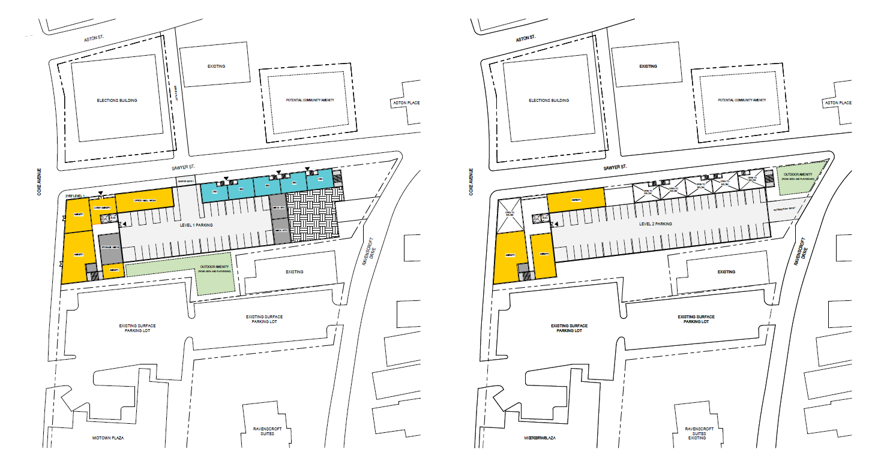
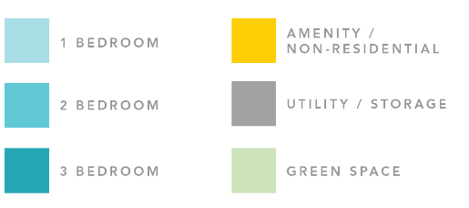

Option 2: 50 & 52 Coxe Avenue

Proposed Development Program
- 200 multifamily (rental) units
All units restricted & affordable to households earning <80% AMI
  - 30% AMI: 42 units
  - 50% AMI: 9 units
  - 60% AMI: 110 units
  - 80% AMI: 26 units
- 5,900 square feet of ground floor, non-residential space
- 120 parking spaces
- Estimated public-private investment: $59 million
  - Potential Buncombe County participation: $9.8 million ($49,000 per unit)
    - Assumes use of both 9% and 4% low-income housing tax credit (LIHTC).

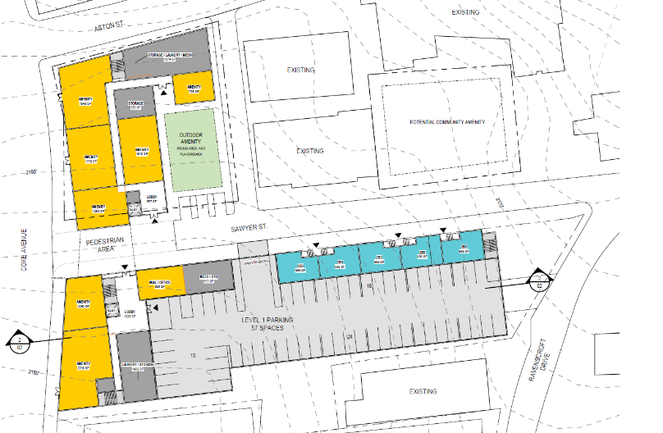

COXE AVENUE
RAVENSCROFT
SAWYER ST.

